Name: Xinyu Hadrian Hu, and Duan Wei Zhang

Student Number: 500194233, and 500824903

TA: Jasminder Singh

Date: June 28, 2020

COE 608: Computer Architecture and Design

COE 608: Lab 4, Part 2 Report

Table of Figures

Figure 1: UZE Truth Table 3

Figure 2: LZE Truth Table 3

Figure 3: Reducer Truth Table 3

Figure 4: Data-path signals truth table 4

Figure 5: LZE Functional Waveform 5

Figure 6: LZE Timing Waveform 6

Figure 7: UZE Functional Waveform 6

Figure 8: UZE Timing Waveform 7

Figure 9:Reducer Functional Waveform 7

Figure 10: Reducer Timing Waveform 7

Figure 11: Data-path Random Input Waveform 8

Figure 12: Data-path Output Functional Waveform 8

Figure 13: Data-path Output Timing Waveform 8

Figure 14: LDAI Operation Waveform 10

Figure 15: LDBI Operation Waveform 11

Figure 16: STA Operation Waveform 12

Figure 17: STB Operation Waveform 13

Figure 18: LDA Operation Waveform 14

Figure 19: LDB Operation Waveform 15

Figure 20: LUI Operation Waveform 16

Figure 21: JMP Operation Waveform 17

Figure 22: ADD Operation Waveform 18

Figure 23: ADDI Operation Waveform 19

Figure 24: SUB Operation Waveform 20

Figure 25: INCA Operation Waveform 21

Figure 26: ROL Operation Waveform 22

Figure 27: CLRA Operation Waveform 23

Figure 28: ANDI Operation Waveform 24

Figure 29: ORI Operation Waveform 25

Figure 30: DECA Operation Waveform 26

Figure 31: ROR Operation Waveform 27

Objective

The purpose of this lab is to put together everything we have done so far, with the addition of the upper zero extender, lower zero extender, and reducer with the program counter, arithmetic logical unit, multiplexers, and operational inverters into a functioning data-path for the MIPS instructional set architecture.

Design and Implementation

I first started with the reducers, LZE and UZE implementations. I did the data-path last. The following truth-tables provide examples of some of the purposes of the LZE, UZE, and reducer. The LZE extends zeroes by padding the bits from 15 down to 0. The UZE does the inverse of the LZE operation by padding zeroes from 31 down to 16. The reducer helps to reduce a 32-bit data into 8-bit data. The data-path is programmed in VHDL using the structural behavior, by utilizing port mapping and signals to denote the wires and buses between the many devices used throughout the course.

The truth tables for each of the new devices are illustrated in the following pages.

See the following figures below: Figure 1: UZE Truth Table, Figure 2: LZE Truth Table, Figure 3: Reducer Truth Table and Figure 4: Data-path signals truth table.



Figure 1: UZE Truth Table

Next, is the Lower Zero Extender Truth Table:



Figure 2: LZE Truth Table

Next, is the Reducer Truth Table:



Figure 3: Reducer Truth Table

Finally, the Data-path Truth Table:



Figure 4: Data-path signals truth table

Observations and Results

Below are the functional and timing waveforms derived for each of the new components listed for this lab.

The following figures are the observations of this project:

Figure 5: LZE Functional Waveform, Figure 6: LZE Timing Waveform, Figure 7: UZE Functional Waveform, Figure 8: UZE Timing Waveform, Figure 9:Reducer Functional Waveform, Figure 10: Reducer Timing Waveform, Figure 11: Data-path Random Input Waveform, Figure 12: Data-path Output Functional Waveform, and Figure 13: Data-path Output Timing Waveform are the figures of interest.

LZE: Functional and Timing

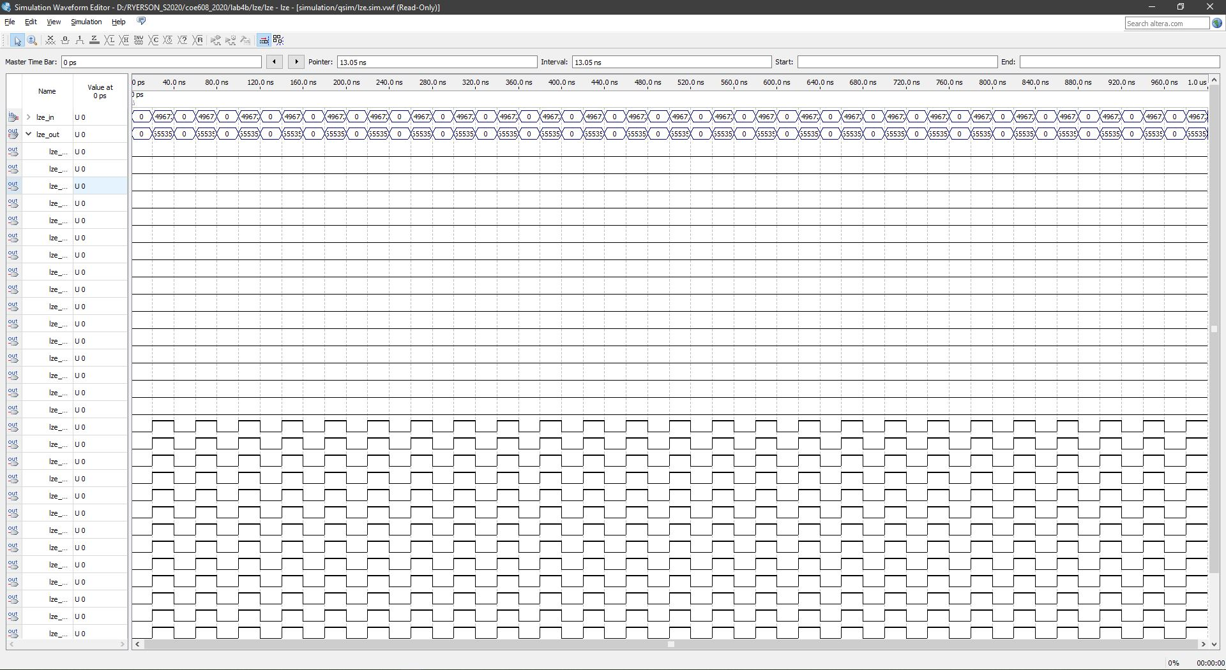

Figure 5: LZE Functional Waveform

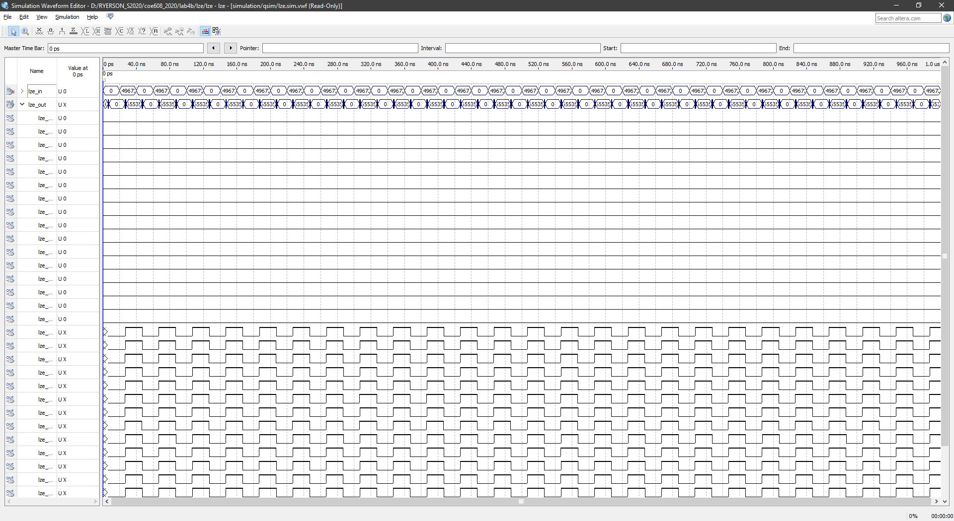

Figure 6: LZE Timing Waveform

UZE: Functional and Timing

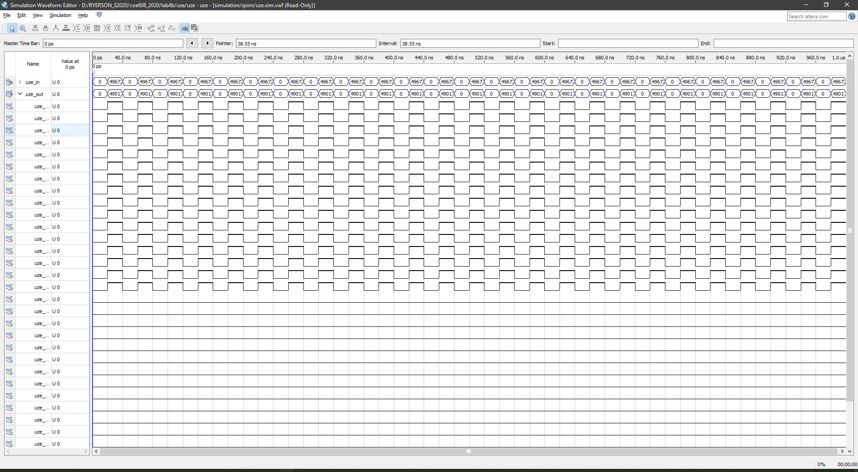

Figure 7: UZE Functional Waveform

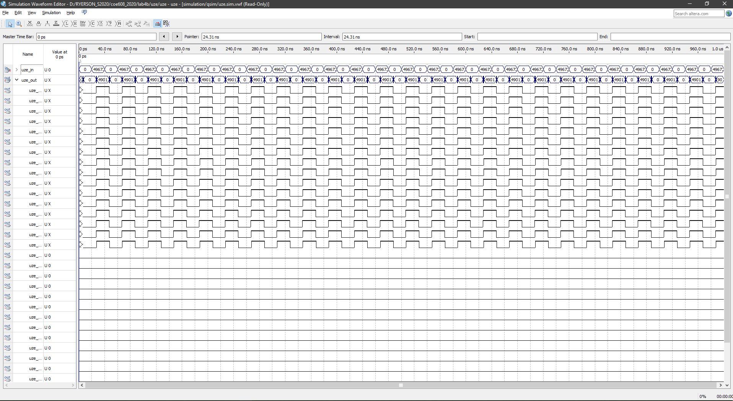

Figure 8: UZE Timing Waveform

Reducer: Functional and Timing

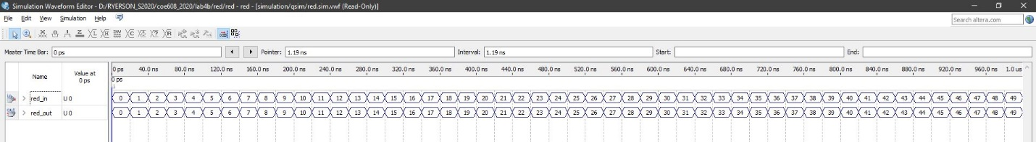

Figure 9:Reducer Functional Waveform

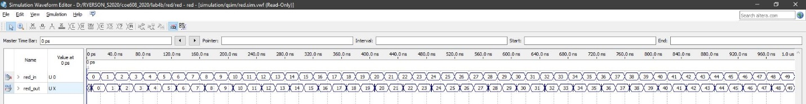

Figure 10: Reducer Timing Waveform

Data-path: Functional and Timing

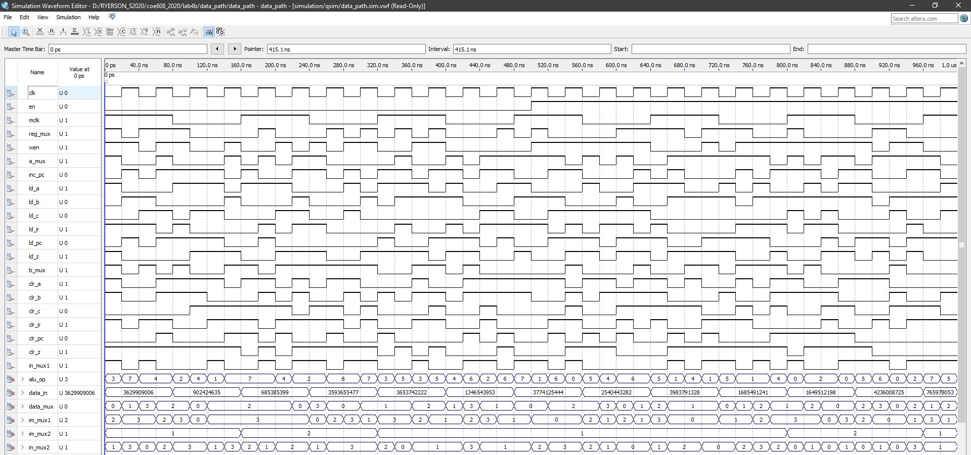

Figure 11: Data-path Random Input Waveform

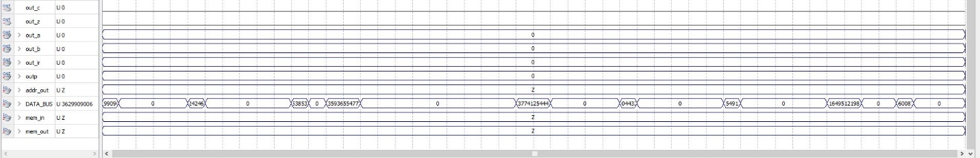

Figure 12: Data-path Output Functional Waveform

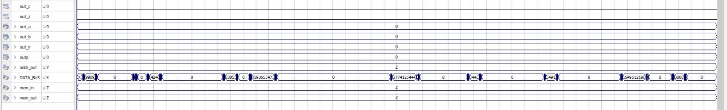

Figure 13: Data-path Output Timing Waveform

For the purposes of understand the operations of MIPS data-path, we have also included the results of specific operations. The random operations waveforms above are not very helpful in demonstrating whether a specific operation works or not.

The following waveform screenshots are courtesy of Duanwei Zhang:

The following figures illustrate the most important operations for the MIPS data-path:

Figure 14: LDAI Operation Waveform, Figure 15: LDBI Operation Waveform, Figure 16: STA Operation Waveform, Figure 17: STB Operation Waveform, Figure 18: LDA Operation Waveform, Figure 19: LDB Operation Waveform, Figure 20: LUI Operation Waveform, Figure 21: JMP Operation Waveform, Figure 22: ADD Operation Waveform, Figure 23: ADDI Operation Waveform, Figure 24: SUB Operation Waveform, Figure 25: INCA Operation Waveform, Figure 26: ROL Operation Waveform, Figure 27: CLRA Operation Waveform, Figure 28: ANDI Operation Waveform, Figure 29: ORI Operation Waveform, Figure 30: DECA Operation Waveform, and Figure 31: ROR Operation Waveform.

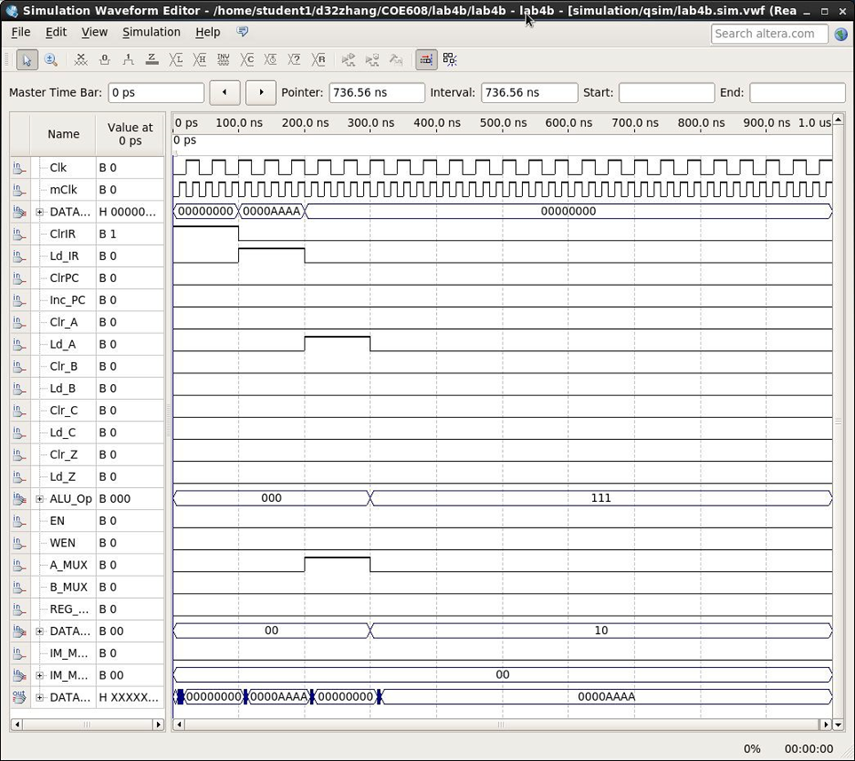

Figure 14: LDAI Operation Waveform

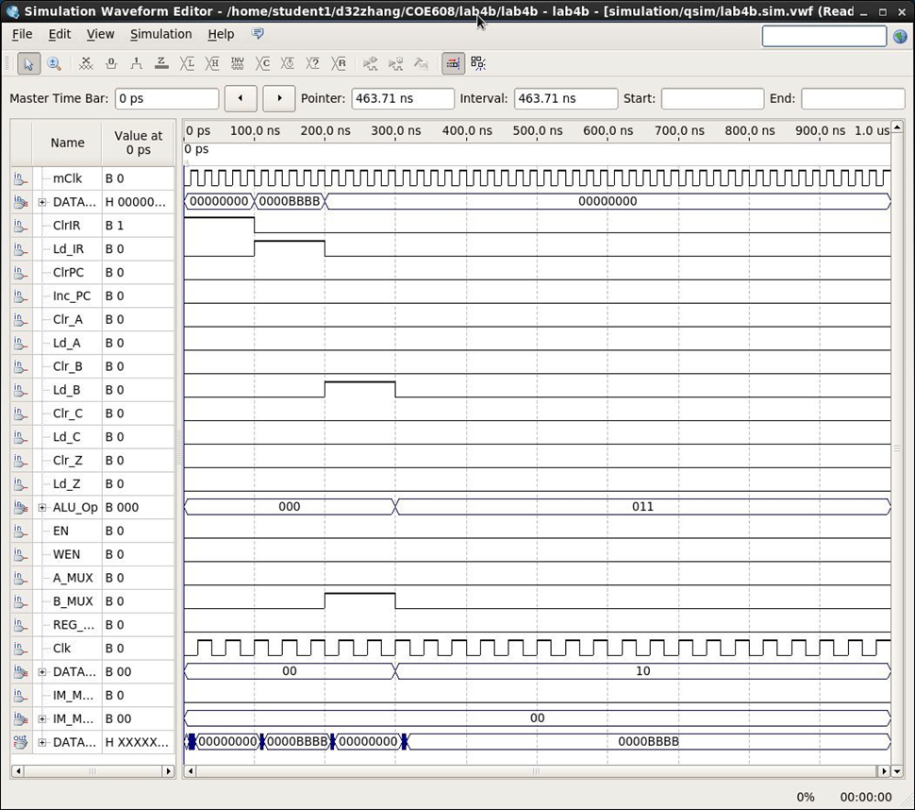

Figure 15: LDBI Operation Waveform

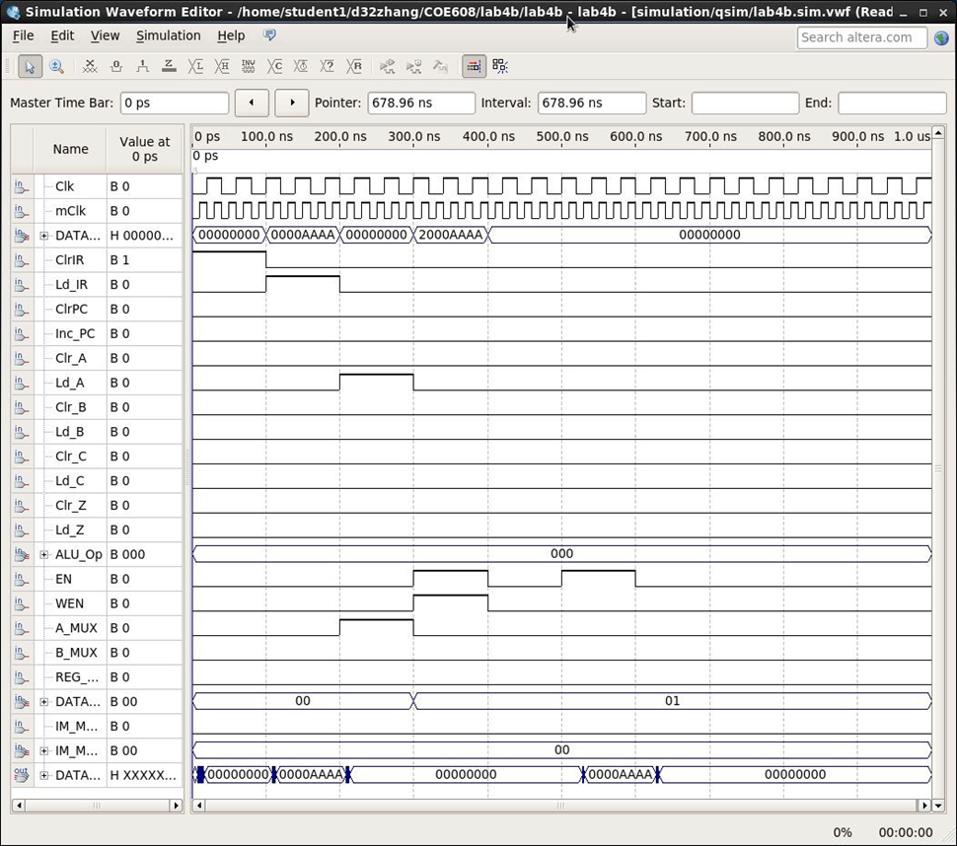

Figure 16: STA Operation Waveform

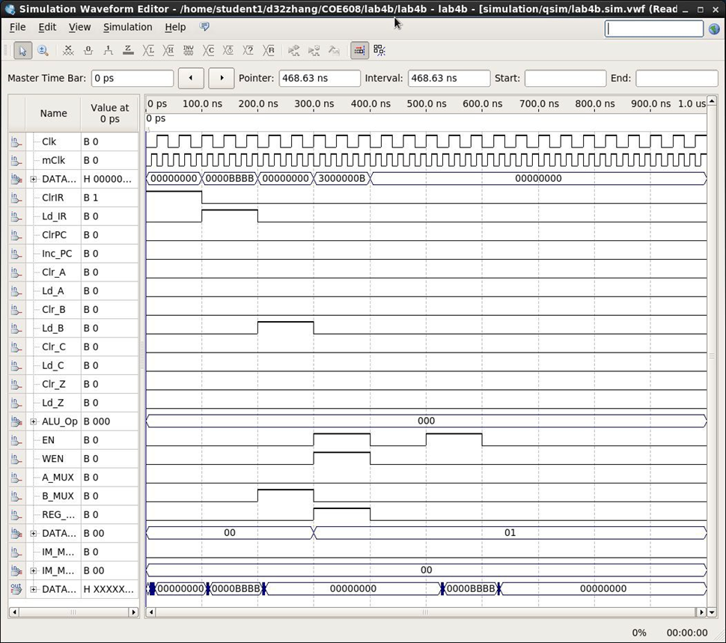

Figure 17: STB Operation Waveform

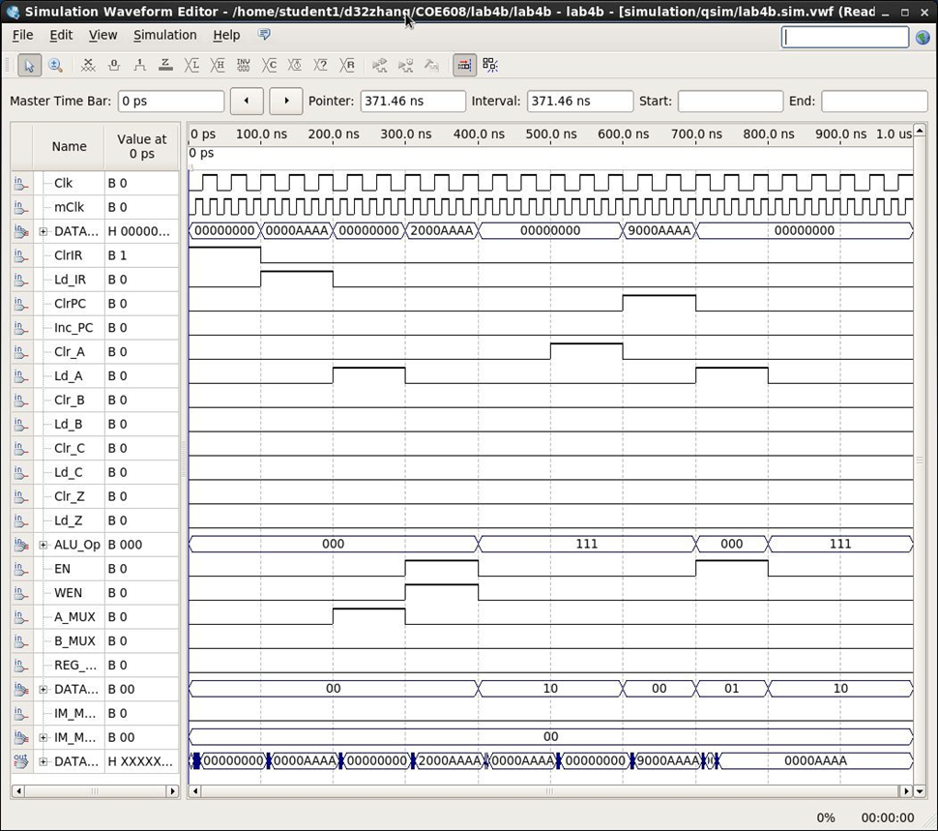

Figure 18: LDA Operation Waveform

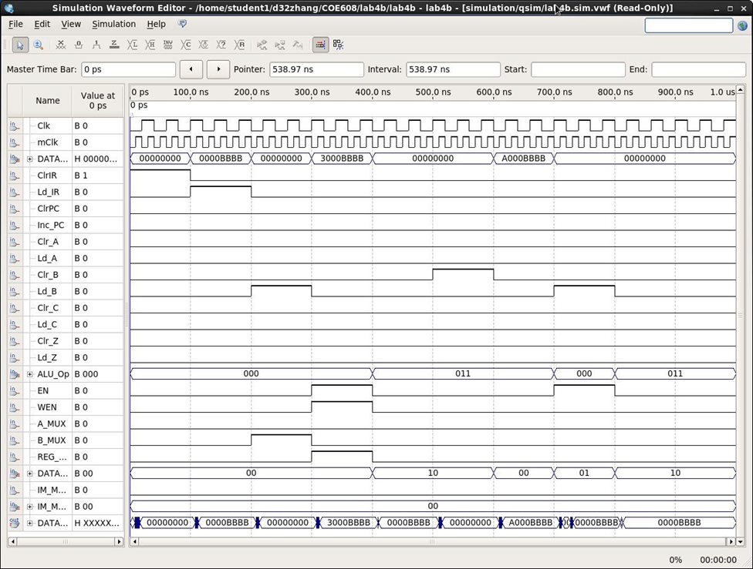

Figure 19: LDB Operation Waveform

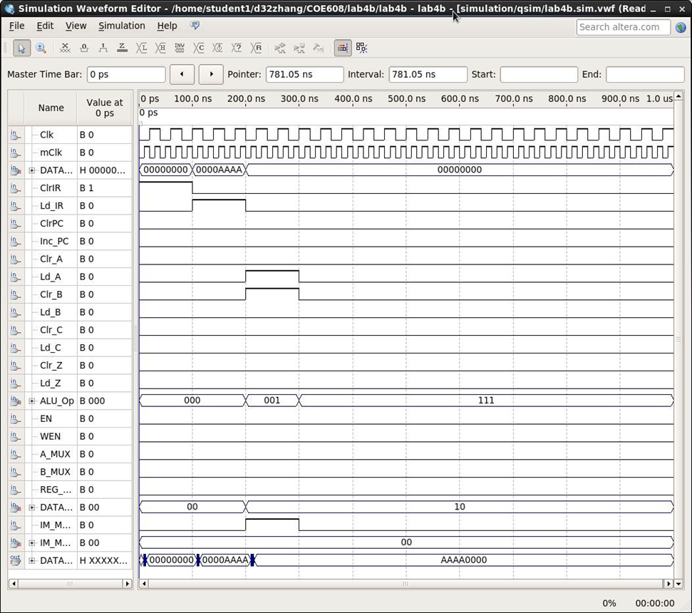

Figure 20: LUI Operation Waveform

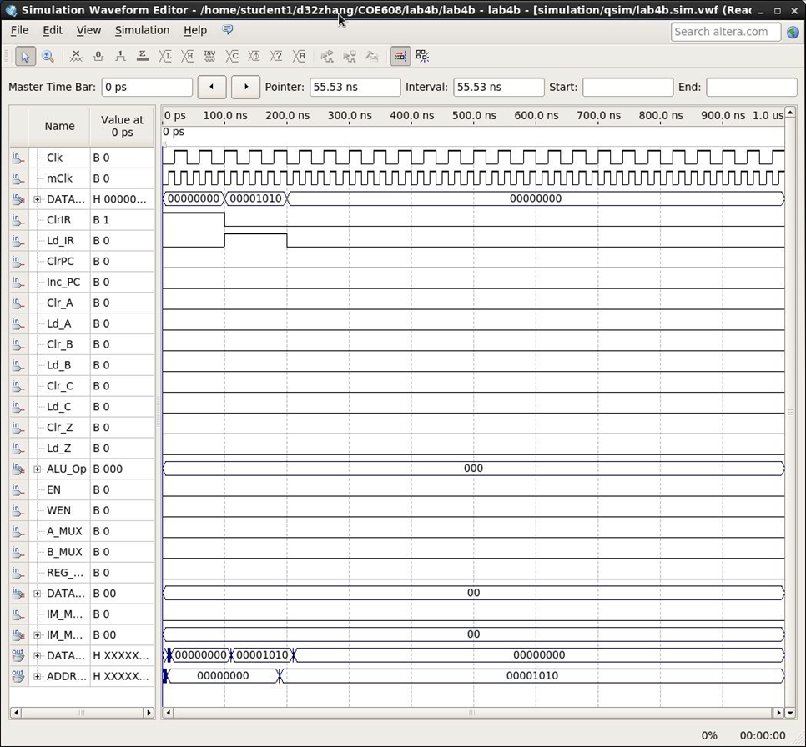

Figure 21: JMP Operation Waveform

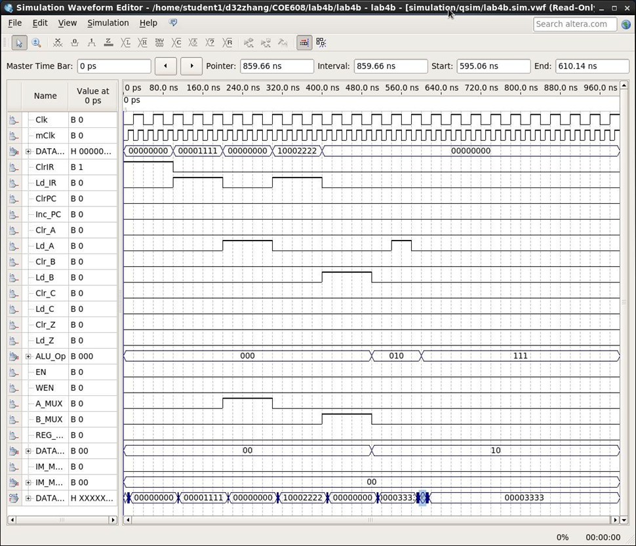

Figure 22: ADD Operation Waveform

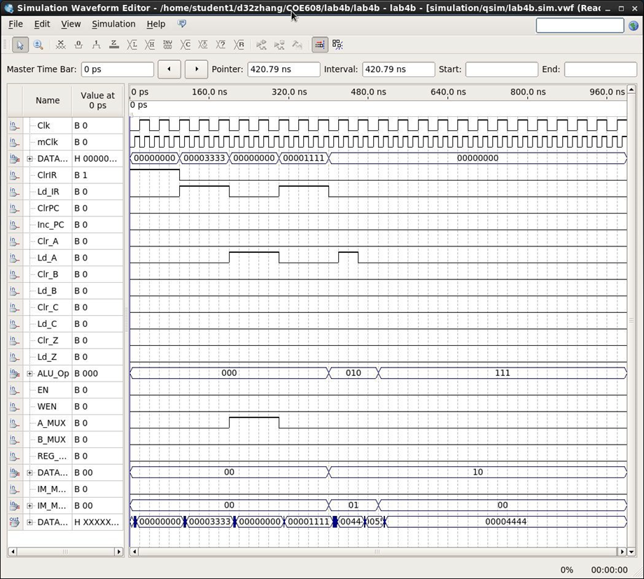

Figure 23: ADDI Operation Waveform

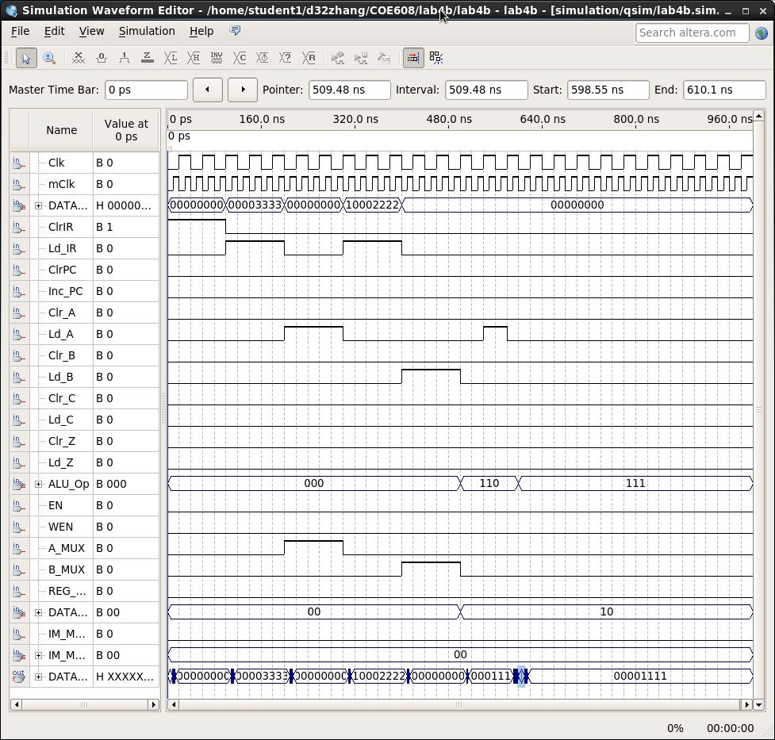

Figure 24: SUB Operation Waveform

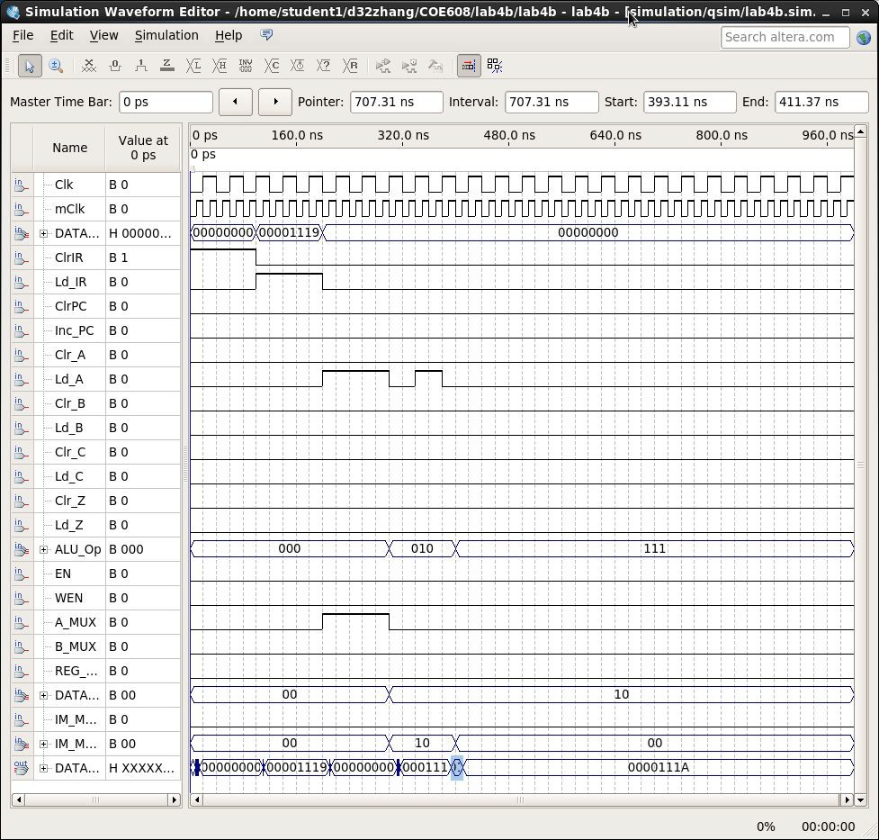

Figure 25: INCA Operation Waveform

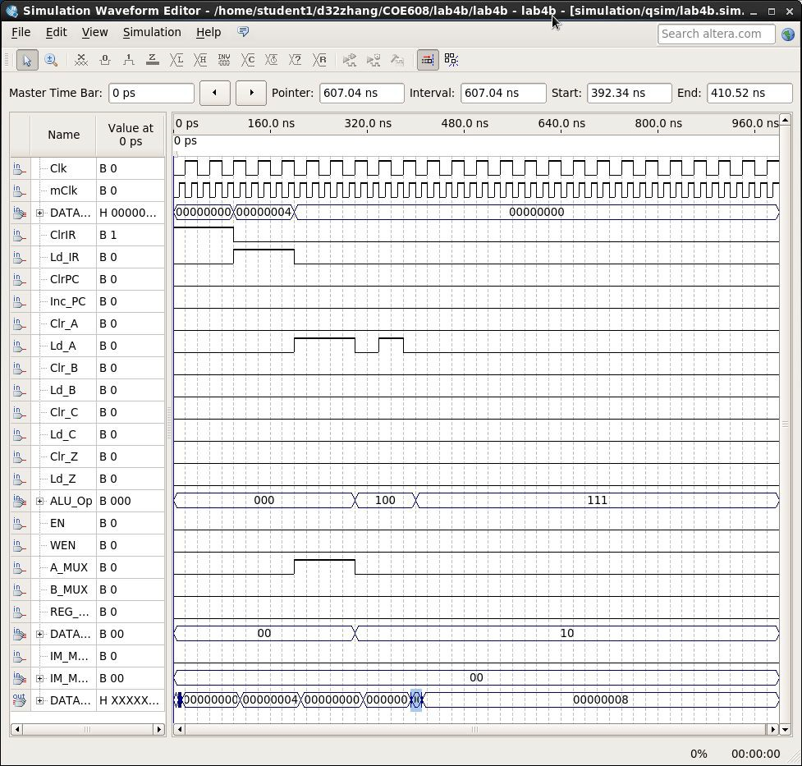

Figure 26: ROL Operation Waveform

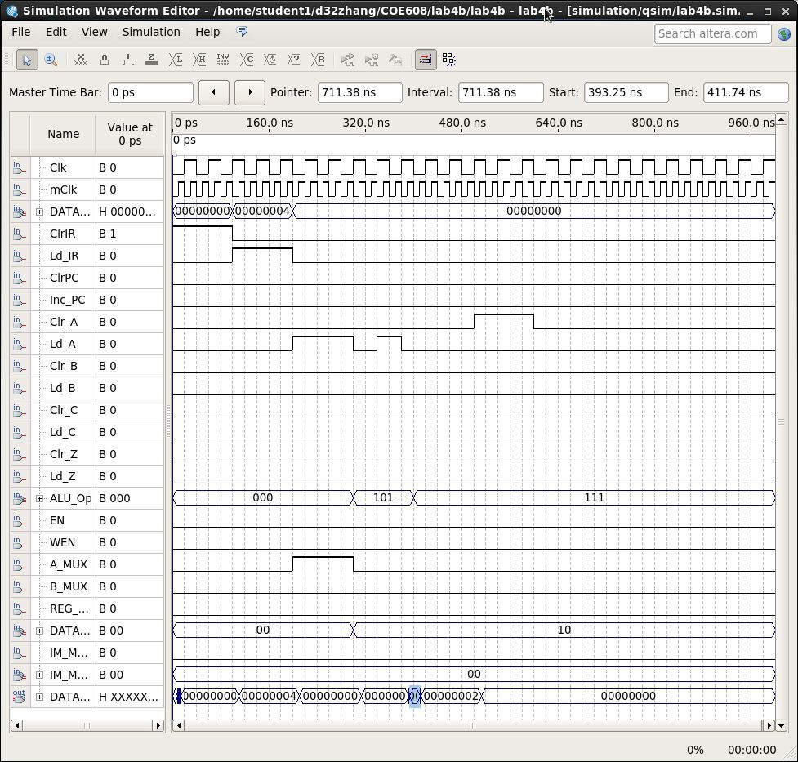

Figure 27: CLRA Operation Waveform

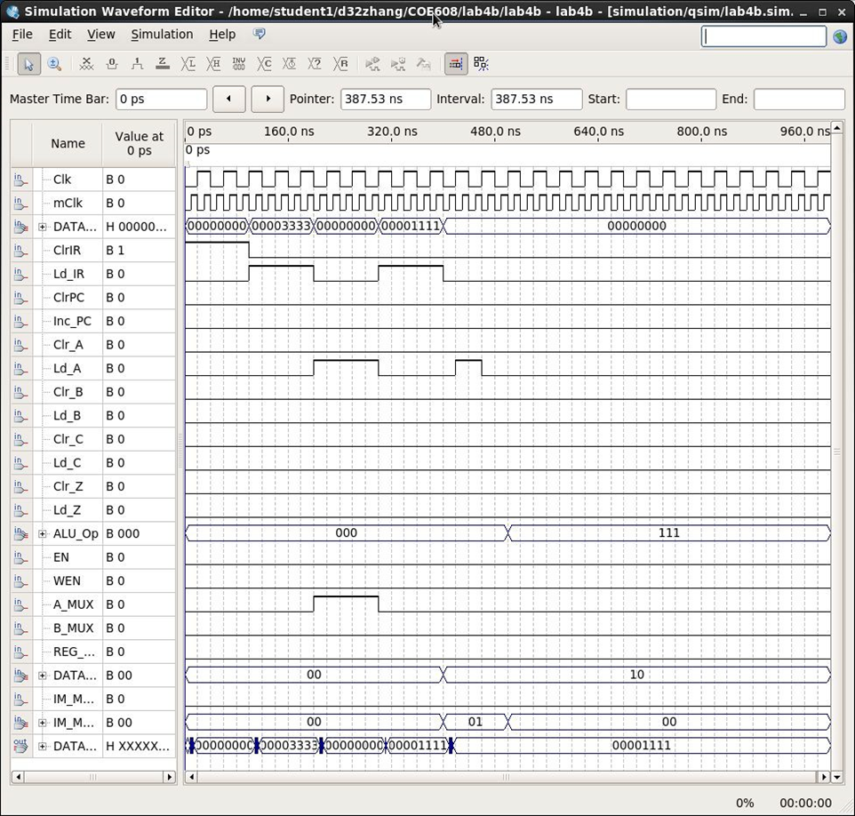

Figure 28: ANDI Operation Waveform

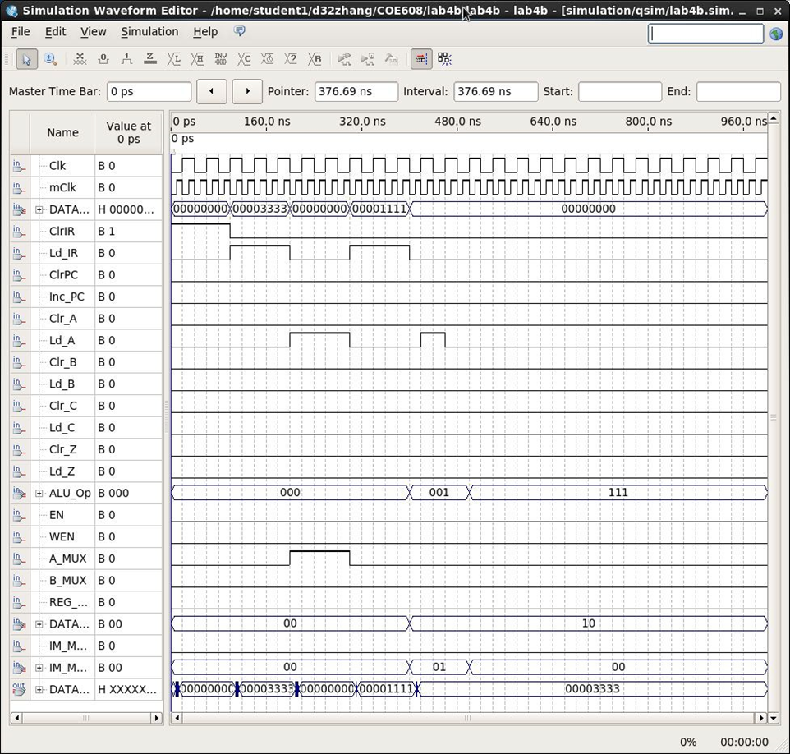

Figure 29: ORI Operation Waveform

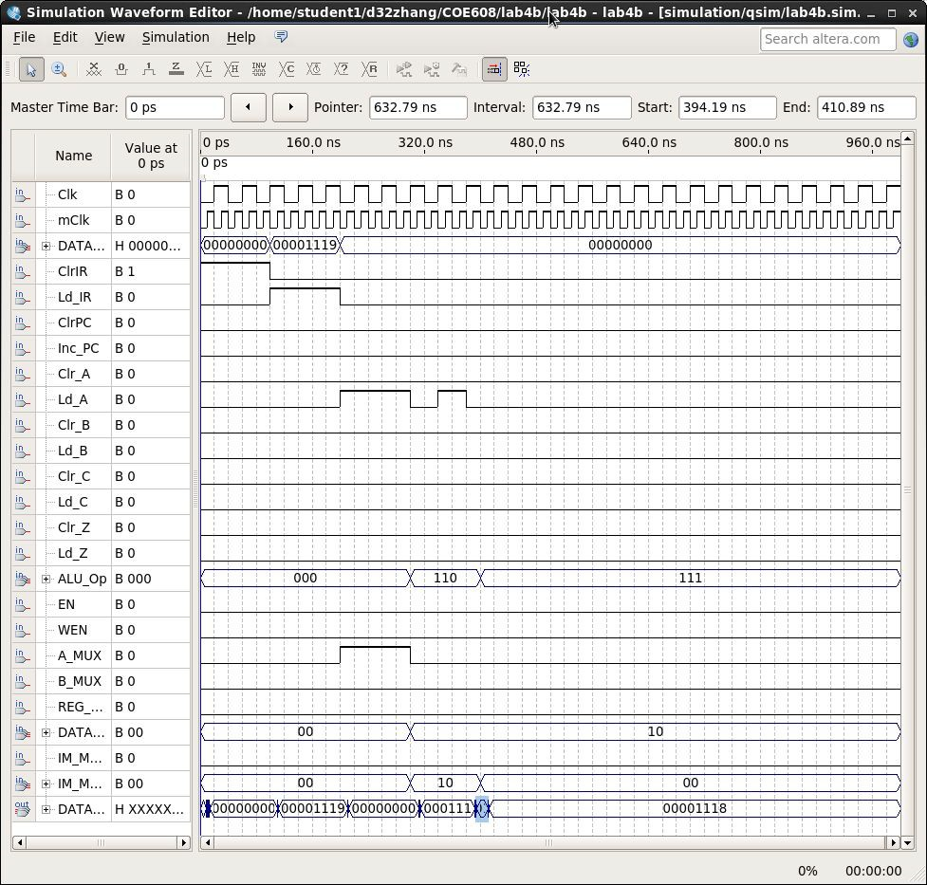

Figure 30: DECA Operation Waveform

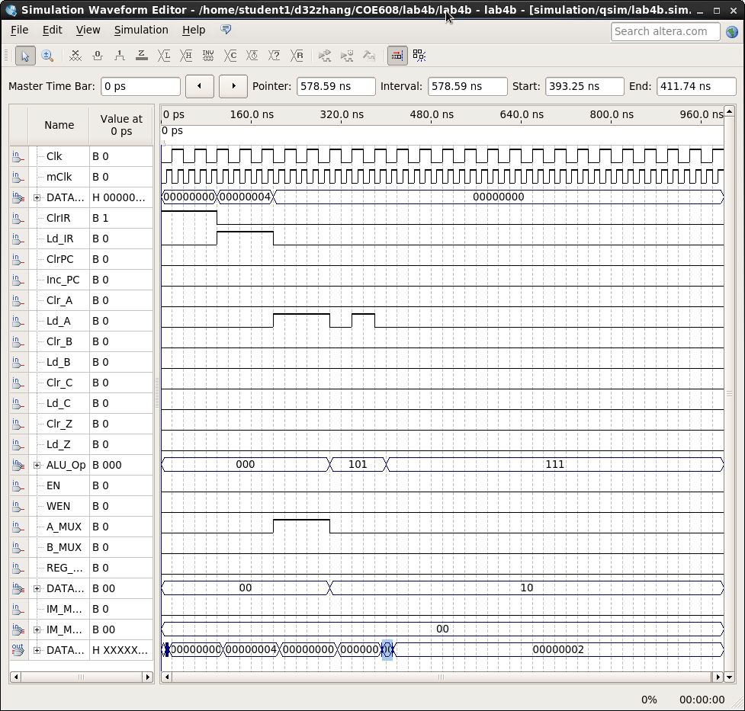

Figure 31: ROR Operation Waveform

Discussions and Conclusions

The data-path implements INCA, ADDI, LDBI and LDA operations by using a finite state machine to select these advanced operations.

The main determinant of the data-path speed is the longest operation performed. In this case, the worst-case timing depends on the operation that is most time-consuming. From Figure 13, it appears the worst-case delay is 10 ns.

The most reliable limit for the data-path clock is 10 ns.

Appendix: VHDL Codes and Screenshots of Waveforms

I have provided the VHDLD and screenshots of the waveforms for easier reading. I also included Duan Wei Zhang’s draft report to include the actual data that was captured in each operation waveform listed from Figure 14 to Figure 31.